Extra Tips for Running a Webinar

Microphone: Due to COVID-19 we have had to record webinars remotely and this has worked very well. However, you do need to ensure that every speaker has access to a decent microphone:

- Ensure that they do not use the laptop’s in-built microphone as the sound quality will not be good enough and you will end up having to re-record the entire webinar
- You may have to lend them a suitable microphone or ask them to borrow one from their communications department - get them to organise this well in advance!
- We have ‘got away with’ iPhone headphones which have a mic, but if these brush against their clothes during the recording, then you will hear ‘bangs’ on the final recording which will ruin the webinar. The same happens if they tap the table with their feet or arms during the recording.
- Make sure they test the microphone with their computer BEFORE the recording day - otherwise you can waste a lot of time trying to help them get the microphone linked to their computer
- Remember the mantra, “no microphone, no recording”!

Recording: When you ‘share screen’ with remote recordings, it is important that the person who is in charge of recording the webinar should have the slides on their desktop. This will ensure that the visual quality of final webinar is good. If someone different is sharing the slide deck remotely then the end webinar will look pixelated and unclear. Hence the person recording the webinar will need to have a clear story board of when to move the slides on for the speakers.

Example: I will often organise, record and edit a webinar but I won’t necessarily be speaking on the webinar. Therefore, I may not have knowledge of the subject in detail and will need clear guidance of when to move the slides forward at the correct times for the speakers.

Ensure that each panellist chooses a quiet room with no noise outside. During COVID many people have been at home which is generally good, and bedrooms are useful spaces due to soft furnishings and carpet which will deaden any echo and improve audio quality.

Computers: we have found repeatedly that our NHS laptops are not powerful enough to successfully download the remote recordings and they have a habit of deleting your precious recordings! This may vary depending on the laptop you have been given. Hence, we have generally used our own laptops as the recording laptop. MAC computers work particularly well. Panellists who are not in charge of recording can use any computer as long as it has a good connection.

WIFI: test this in the practice session. On several occasions we have had to relocate speakers at the last minute as the room they chose to use had poor signal strength which resulted in unusable audio quality.

Patient access to your webinar: Although we have set up our own website, that is not possible or necessary for everyone making patient webinars. However, YouTube is incredibly useful, and you can use the YouTube link for your particular webinar wherever it is most accessible i.e. you could text it directly to patients, send it via email, place it on the Trust website on a dedicated page, or simply direct patients to your YouTube page. You could do the same with the outcome surveys.

Images - Canva: Very useful website for copyright-free images and creating easy social media designs for marketing your webinars. They have dedicated templates for Instagram, YouTube, Facebook and Twitter and you can make infographics and PowerPoint templates… and more. We have a department account. Worth every penny! https://www.canva.com/en_gb/

And finally…

If helpful, then please do print off any of the documents mentioned in the webinar from this page on our website.

And here is a copy of our flow chart giving a rough outline of the time needed and process for making a webinar:

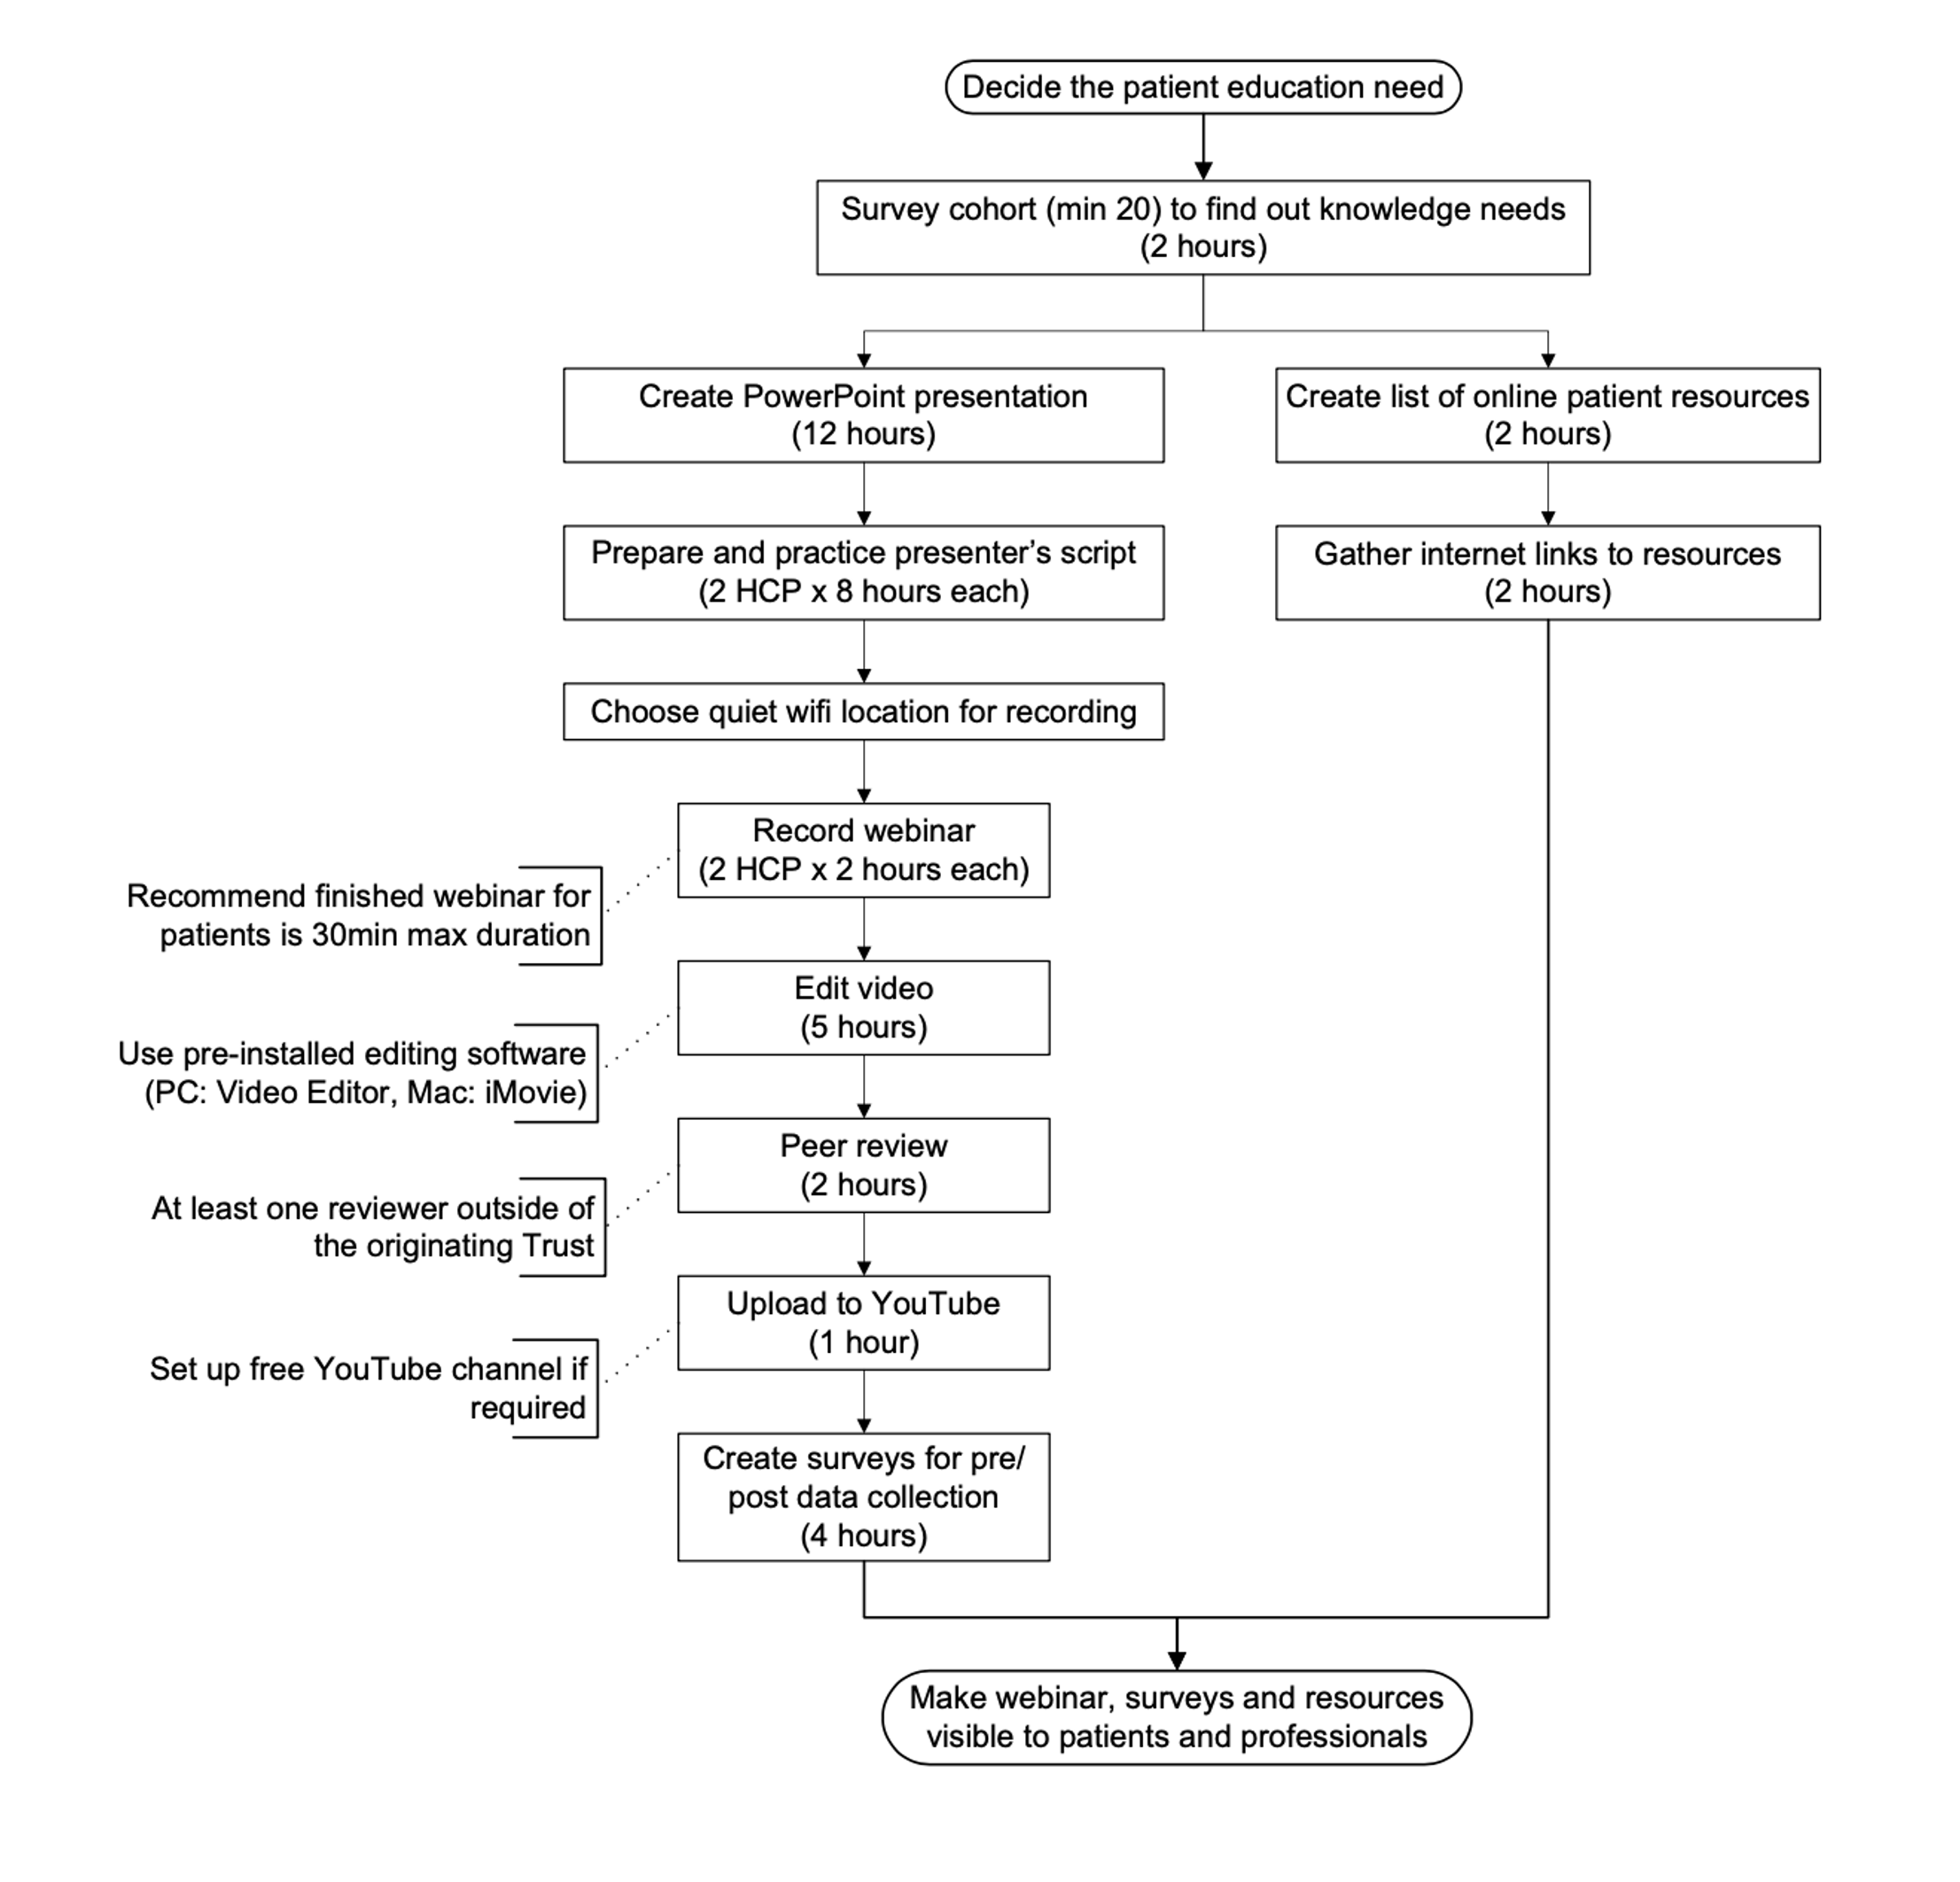

By Marianne Williams, Dietetic ACP, Somerset NHS Foundation Trust 2021

