Outpatient Dietetic Service
Weight Management Printable Self-Referral Form
PLEASE NOTE: We can only provide a dietetic service to patients registered with a Somerset GP with either a Body Mass Index (BMI) of
- >35kg/m2 OR
- >30kg/m2 with comorbidities. Recognised comorbidities include cardiovascular disease, high blood pressure, high cholesterol, Type 2 diabetes ONLY, idiopathic intracranial hypertension, obstructive sleep apnoea, osteoarthritis, polycystic ovary syndrome, and non-alcoholic fatty liver disease.
If you are overweight (>25kg/m2) but do not meet the above criteria, please visit the Healthy Somerset website at www.healthysomerset.co.uk/weight/ for further information on weight loss programmes in your area.
This service provides specialist advice to support people that wish to lose weight and have a BMI of at least 30kg/m2. This self-referral form should be completed if you are finding it difficult to lose weight after implementing the dietary advice recommended in the webinars.
This service is not able to prescribe weight loss injections or weight loss medication. If you would like further information about these treatments or would like to know whether you would be eligible, please contact your GP.
Patient Details
Name |  | Date of Birth
NHS Number (if known)
Address
Postcode
Email |  | Telephone Number
GP Name
GP Surgery
If you are completing this form either with or on behalf of the patient, please provide further information by filling in the boxes below.
Does the patient consent to this referral being made: Yes No*
Your name |  | Your relationship to the Patient named  above
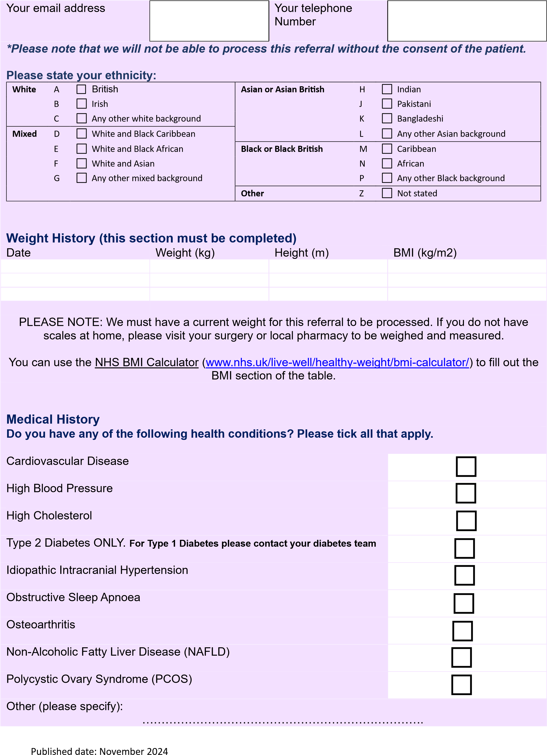

PLEASE NOTE: If you have a BMI of less than 35kg/m2 and do not have any of the above health conditions, your referral will be rejected, and you will not be offered an appointment.
Aims
Please state what you would like to achieve by seeing a dietitian.

Please fill in the form and either:
Post to: Community Dietitians, Administration Suite, 1st Floor, Bridgwater Hospital, Bower Lane,
Bridgwater, Somerset, TA6 4GU.
Please note that this is a correspondence address only. Please do not hand return self-referral forms to this address, as we cannot guarantee that it will safely reach us. We thank you for your understanding.
Email to: dieteticsreferrals@somersetft.nhs.uk
Please note that using public email services is not secure. Somerset NHS Foundation Trust cannot accept responsibility for any email correspondence until it reaches us. We will send you an acknowledgement to confirm receipt of your email. You may wish to consider sending your email encrypted. If you are in any doubt about sending your form by email, then you should post this to us at the address at the top of this self-referral form.
Thank you for completing this form.
What happens next?
Once you have completed this form, please post it to us using the details above.
Your referral will be triaged by a dietitian, and you will be offered an appointment, if appropriate. If you have not heard back from the dietetic service within 4 weeks, please contact us on 01278 447407 to check that we have received your referral.

