Nutrients resource
Dementia webinar
Links below
www.gov.uk/government/publications/the-eatwell-guide/the-eatwell-guide-how-to-use-in-promotional-material

www.nhs.uk/live-well/eat-well/food-guidelines-and-food-labels/the-eatwell-guide/

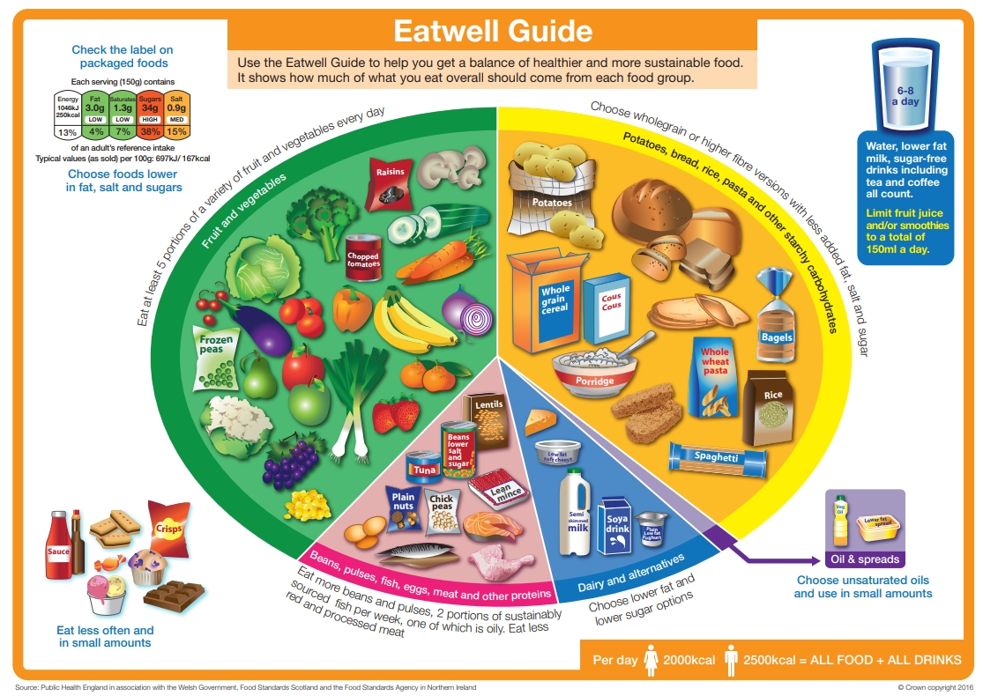

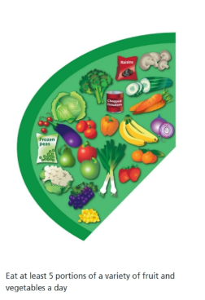
Fruits and vegetables should make up just over a third of the food we eat every day. Aim to eat at least 5 portions of a variety of fruit and vegetables each day. This can be fresh, frozen, tinned, dried or juiced. Fruit juice and smoothies should be limited to no more than 150ml per day.

Starchy carbohydrates should make up just over a third of the food we eat. Choose higher fibre or wholegrain options, such as brown rice and pasta or leave skins on potatoes.

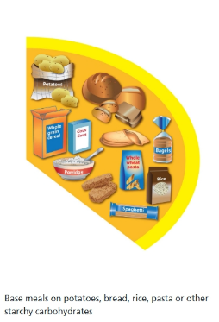

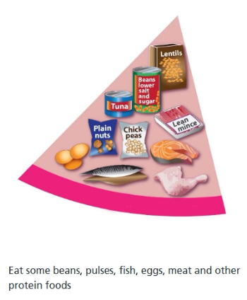
Protein foods come from animal and plant sources. When choosing animal sources, opt for lean cuts of meat and mince, and eat less red and processed meats such as bacon, ham and sausages. Other animal sources include fish and eggs. Plant-based sources include nuts, soya mince, tofu, and pulses such as beans, peas and lentils. Plant-based sources are often lower in fat and contain more fibre than animal sources.

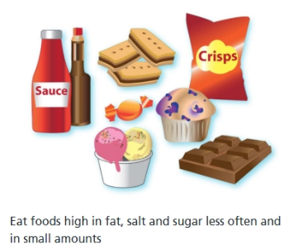
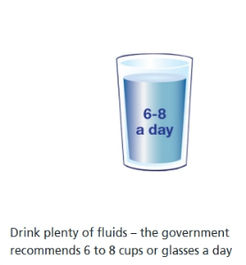
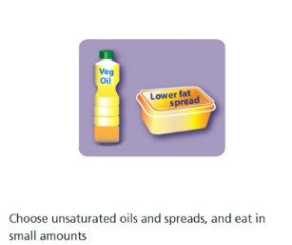
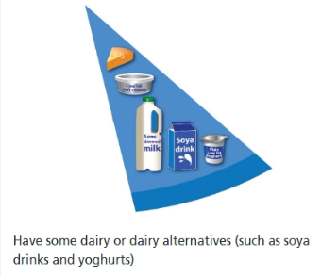
Unsaturated fats are healthier fats, including vegetables, rapeseed, olive and sunflower oils. In the latter stages of dementia, it is not as important to focus on healthier fats.

Foods high in fat, salt and sugar should be eaten less often and in small amounts. This includes chocolate, cakes, biscuits, sugary soft drinks, butter, ghee and ice cream. In the latter stages of dementia, it is not as important to reduce these.

Drinking fluids can help prevent dehydration. This includes water, milk, low sugar or sugar-free drinks, teas and coffees. Fruit juice and smoothies also count towards fluid intake, but contain sugar which can damage teeth so limit these drinks to 150ml per day. However, restrictions can be lifted in latter stages of dementia as these may be a valuable way of getting calories and hydration into someone.
Dairy and dairy alternatives are also a good source of protein as well as calcium and vitamins. Sources include cheese, yoghurts, milks and creams. Some people may prefer skimmed or semi-skimmed milk and reduced-fat cheese, however in the latter stages of dementia, it may be beneficial to opt for full fat versions if eating and drinking has decreased.

